**Problem 1**

P3

11-P

P11

P10

10-P

5-P

9-P

8-P

P7

7-P

P8

P5

4-P

P4

2-P

P2

P1

1-P

P

12

**A**

11

10

9

1

2

4

5

6

7

8

3

11

9

7

12

10

8

6

5

4

3

2

1

P6

6-P

P9

3-P

C

60π ≈ 188.5 mm

**Problem 2**

**USE SUITABLE SCALE**

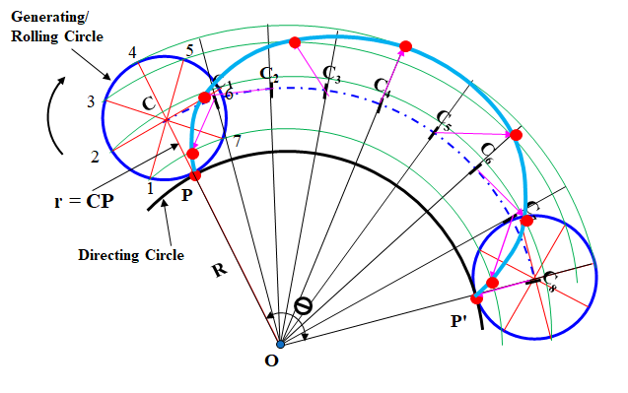

**ϴ = r/R x 360º**

**= 0.45/1.5 x 360º**

**= 108º**

**R = 1.5 m**

**= 0.45 m**

**Problem 3**

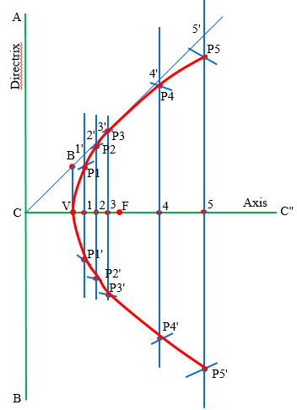

**20 mm**

**40 mm**

**Problem 4**

**120 mm**

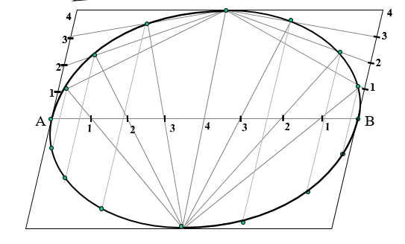

**70º**

**50 mm**